SET 7 : Bar Chart – Distribution of Customer Ages
Aim:
To visualize the distribution of customer ages using a bar chart.
R Code:
customer_data <- data.frame(
Customer_ID = c(1, 2, 3),
Age = c(28, 35, 42),
Gender = c("Female", "Male", "Female"),
Income = c(50000, 60000, 75000)
)

barplot(customer_data$Age,
names.arg = customer_data$Customer_ID,
col = "skyblue",
main = "Distribution of Customer Ages",
xlab = "Customer ID",
ylab = "Age")
Observation:
Customer 1 is 28 years old, Customer 2 is 35 years old, and Customer 3 is 42 years old.
Output:
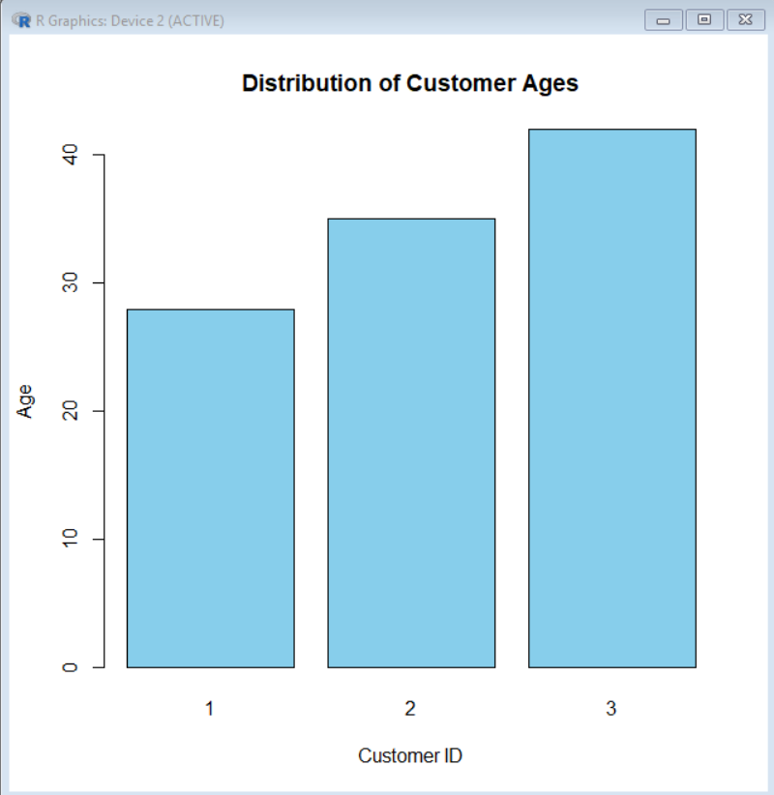

Q2. Pie Chart – Customer Gender Distribution
Aim:
To represent the distribution of customers by gender.
R Code:
gender_count <- table(customer_data$Gender)

pie(gender_count,
main = "Customer Distribution by Gender",
labels = paste(names(gender_count), gender_count))
Observation:
There are 2 female customers and 1 male customer.
Output:
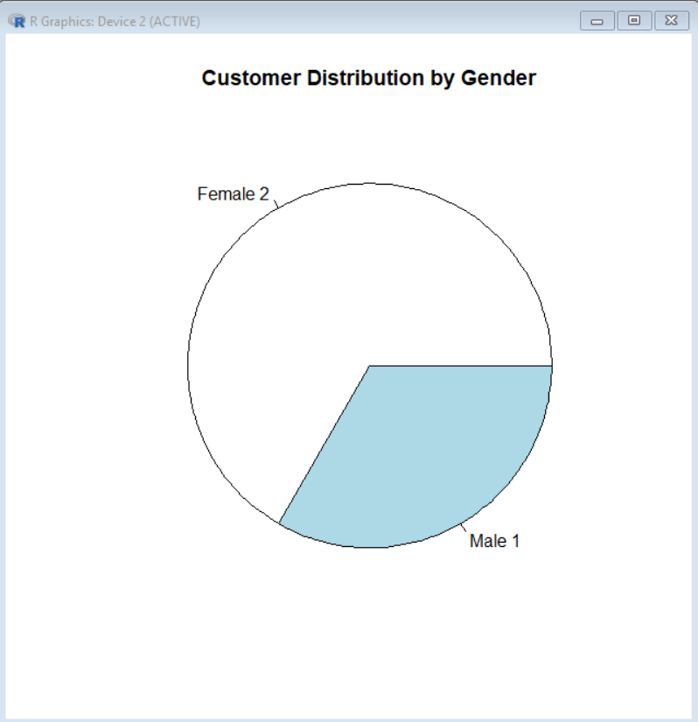

Q3. Demographic Information Table
Aim:
To display the demographic information of each customer.
R Code:
print(customer_data)
Table:
Customer ID | Age | Gender | Income ($)
1 | 28 | Female | 50,000
2 | 35 | Male | 60,000
3 | 42 | Female | 75,000
Table Elements:
- Customer ID – identifies each customer
- Age – customer's age
- Gender – customer's gender
- Income – customer's income
Output:
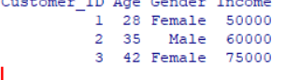

Q4. Tableau Dashboard
Dashboard Components:
- Customer Age Bar Chart
- Gender Distribution Pie Chart
- Customer Demographic Table
Procedure:
- Import the customer dataset into Tableau.
- Create a Bar Chart using Customer ID and Age.
- Create a Pie Chart using Gender.
- Create a Table using Customer ID, Age, Gender and Income.
- Create a new dashboard.
- Drag all three sheets into the dashboard.
- Add filters if required.
- Arrange the charts for easy viewing.
Result:
An interactive Tableau dashboard is created to explore customer age, gender and income information.

